**Updating One2many Field in Onchange**

**Step 1: Define the Models**

You need two models:

1. practice.school (Parent Model)
2. practice.students (Child Model)

**Step 2: Define the Parent Model (practice.school)**

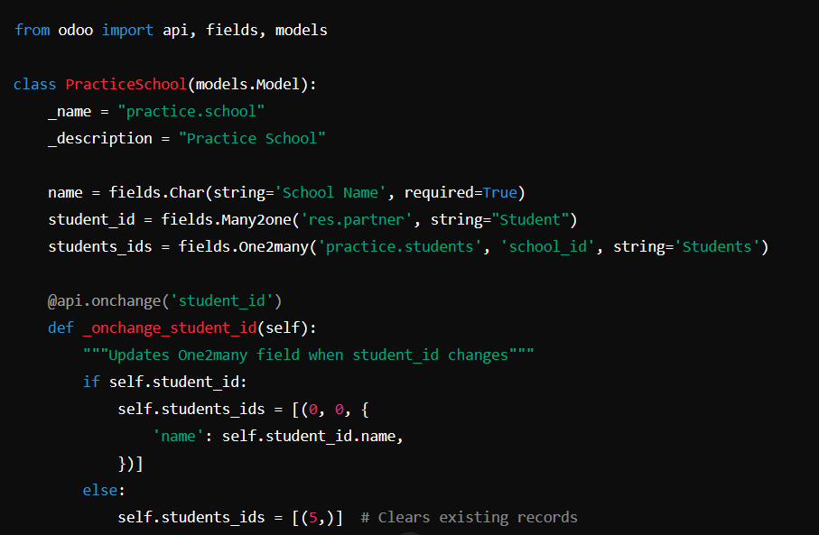

**Step 3: Define the Child Model (practice.students)**

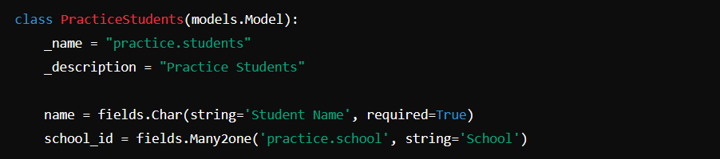

**Step 4: Understanding the Special One2many Commands**

In Odoo, when updating a **One2many** field, you can use special commands:

| **Command** | **Description** |
| --- | --- |
| (0, 0, values) | Creates a new record with given values. |
| (1, id, values) | Updates an existing record with the given ID. |
| (2, id, 0) | Deletes a record from the database. |
| (3, id, 0) | Unlinks (removes) a record from the One2many field but does not delete it. |
| (4, id, 0) | Links an existing record (ID) without modifying it. |
| (5,) | Removes all records from the One2many field. |